## Lab_Day-6 ANP-C9180 (While Loop)

**Q1. Write a python program to reverse a number using a while loop.**

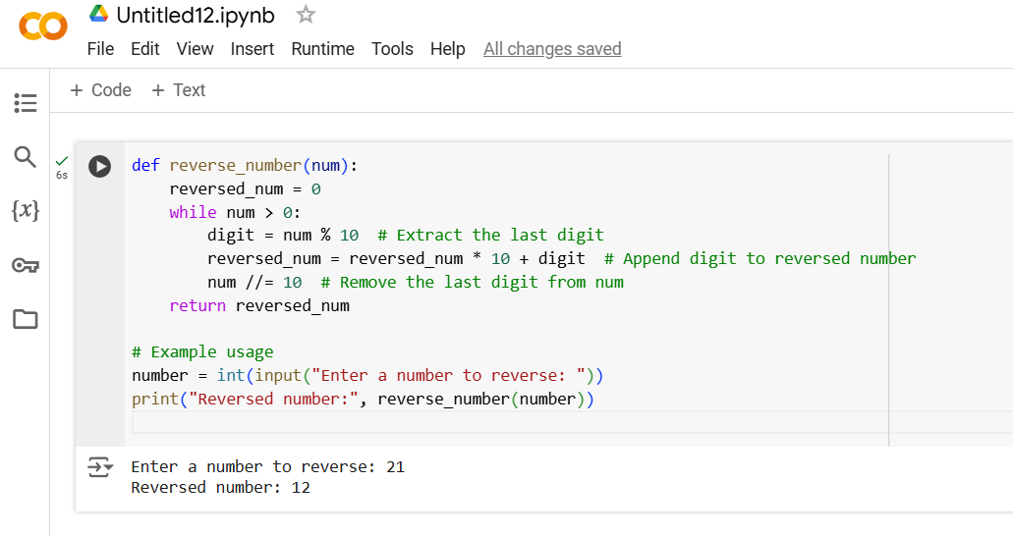

**Q2. Write a python program to check whether a number is palindrome or not?**

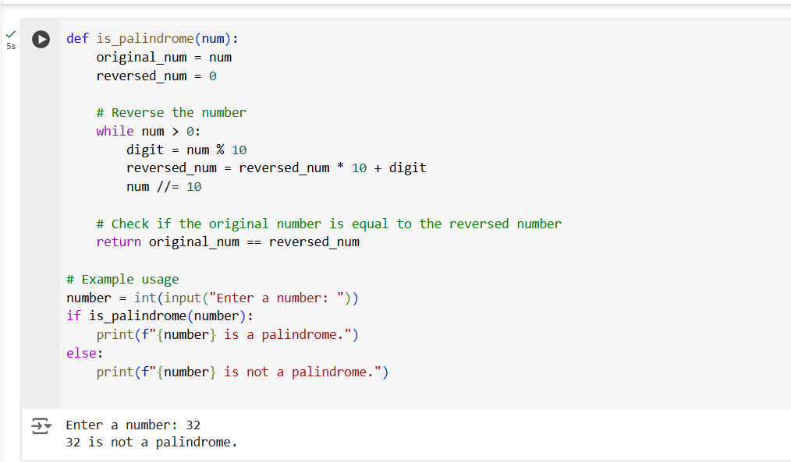

**Q3. Write a python program finding the factorial of a given number using a while loop.**

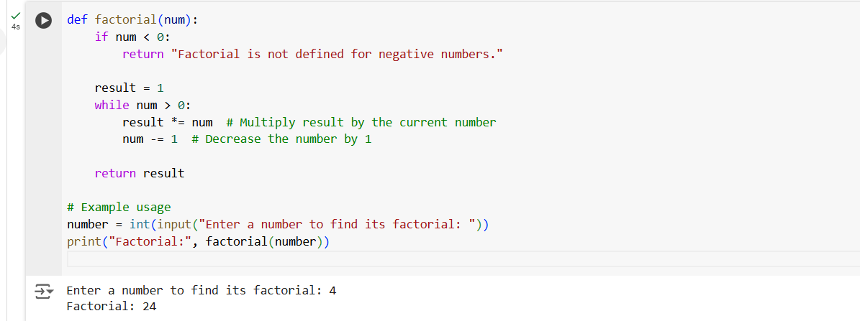

**Q4. Accept numbers using input() function until the user enters 0. If user input 0 then break the while loop and display the sum of all the numbers.**

